# **Office Supplies Sales Analysis - Excel**

## **Calculations**

### Orders + Returns

For my analysis of the Office Supplies orders and returns dataset, my first approach was to link the Returns data to the primary Orders table. To do this I used the following formula in a new column titled ‘Returned?’:

*=IF(ISNUMBER(MATCH([@[Order ID]],'Returns'!$B$3:$B$298,0)),"Yes","No")*

This formula checks if the Order ID for that row appears in the Returns table, and returns as Yes if it does, and No if it doesn’t.

### Actual Profit

To calculate the total actual profit (taking returns into account), I created a new column in the Orders table, with the following formula:

*=IF([@[Returned?]]="no",[@Profit],0)*

This formula checks the new ‘Returned?’ column and returns a £0 if the item has been returned, or the actual profit if it has not. As returned items are refunded this takes this into account.

### Total Sold and Return Rates by Product

I created a new sheet with all the distinct products and calculated Total Sold per product using:

*=SUMIFS(Quantity,Orders[Product Name],E6)*

Total returned by product:

*=SUMIFS(Quantity,ProductName,E6,Returned?,"Yes")*

And finally, I calculated the return rate for each product:

*=Total Returned / Total Sold*

## **Analysis**

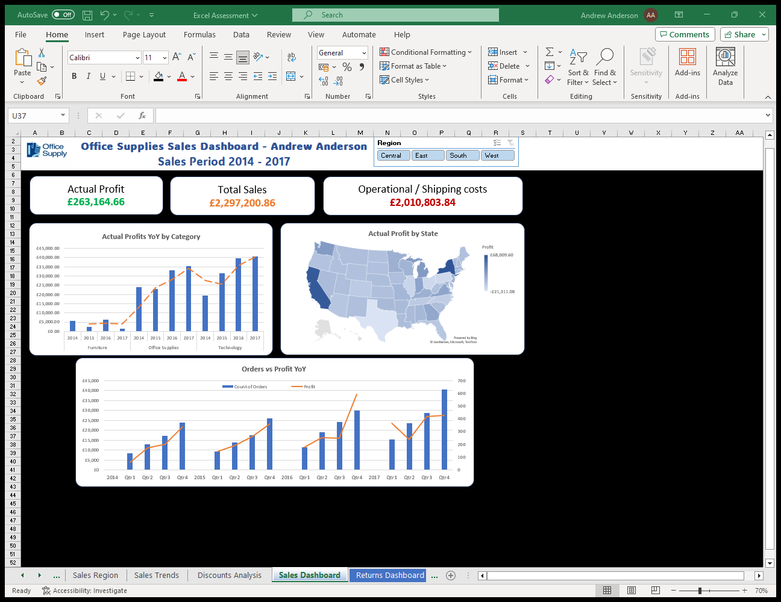First, I created a general Profit/Sales dashboard:

The **Actual Profits YoY by Category** chart shows us that products in the Technology category have seen steady increase in profits over 4 years. Office supplies have also seen increase, though had a very slight drop in 2015, whereas products in the Furniture category have had stagnated profits over those 4 years.

The **Actual Profit by State** map shows us that California and New York have been by far the most profitable locations for business, with Washington bringing in decent profits. On the other hand, business in Texas, Illinois, Ohio, Pennsylvania, North Carolina, and Colorado has actually been making a loss, indicating that there may be an issue with shipping costs, or customer satisfaction in those locations.

The **Orders vs Profit YoY** chart shows us how order quantity and profits have increased over time. We can see across the 4 years that Q4 generally sees an increase in orders, and profits are respective of that between 2014 and 2016. However, in 2017 profits struggled, with a dip in Q2 and stagnation between Q3 and Q4, despite the typical increase in orders. We can also see that although 2017 saw an overall increase in orders across all four quarters, profits struggled to exceed the previous year.

Then I created a Returns Analysis Dashboard:

I calculated the **Returns Profit Loss** by subtracting the Actual Profit (after accounting for returns) from the original Profit figure.

The **Highest Return Rate Products** chart shows us the top 10 Products that have the highest return rates. We can see that the top 8 have a return rate of 100% indicating that there is a serious fault with the product, this could be a manufacturing defect, or an issue with the shipping method for those specific products resulting in damage.

The **Return Rates by Sub-Category** chart gives us a broader view of return rate trends, indicating that products from the Machines and Fasteners catgegorues have the highest average return rates, and products from the Art and Envelopes categories have the lowest average return rates.

Finally, I created a Discounts analysis dashboard:

The two map charts, **Actual Profit by State** and **Average Discount by State**, when compared together, show us that Texas, the state with the highest average discount rate, is also making the most loss for the business. This indicates an issue with discount allocation and requires revisiting by the Sales or Discounts team to evaluate the current sales plan in that state. The central USA states generally have lower discount rates, but also bring in low profits. California on the other hand, looks to be a Sales tactics success story: an appropriate discounting strategy in California is resulting in high profits.

The two bar charts, **Actual Profit by Category** and **Average Discount by Category**, show us that there is a failing discount strategy with Machines, Tables and Bookcases, as they have the highest discount rates, and the lowest profits, and even losses, within their categories. Supplies are also seeing losses, although the average discount is similar to others within the Office Supplies category. When the discount strategy is revisited and reevaluated for those failing product categories, the discount strategy for Accessories, Phones and Copiers can be used as it is much more successful, seeing high profits. The Binders category is an outlier in this analysis as having the highest average discount rate yet seeing fair profits.

## **Actions**

1. The Furniture product category requires investigating: there are several possible reasons for the stagnation in profits within this category, these could include:
   1. Poor Pricing or Discounting strategies
   2. Product Quality issues
   3. Ineffective Marketing
2. There are significant deviations in profits across different states geographically, there are several possible reasons for this that should be reviewed:
   1. Shipping Costs
   2. Customer Satisfaction
   3. Regional Market Demand
3. The products with the highest return rates should be thoroughly investigated too, especially the products with 100% return rate. Quality control measures should be increased or implemented, and product descriptions should also be adjusted to manage customer expectations. The following areas should also be investigated:
   1. Manufacturing Defects
   2. Packaging Issues
   3. Shipping Methods
4. The discounting strategy should be thoroughly investigated in the state of Texas, and per product category, especially the Machines, Tables and Bookcases. The discounting strategies on the more profitable products should remain the same and used as a successful strategy example.